-- Task 1: Identify Top Students by Total Scores
-- ● Use a subquery to calculate the total score (math_score + science_score +
-- english_score) for each student.
-- ● Use an ORDER BY clause to rank students by their total scores in descending order.
-- ● Limit the results to show only the top students (e.g., top 5).

SELECT StudentID, Name, Gender, Age, Grade, MathScore, ScienceScore, EnglishScore,
(MathScore + ScienceScore + EnglishScore) AS TotalScore
FROM Students
ORDER BY TotalScore DESC
LIMIT 5;
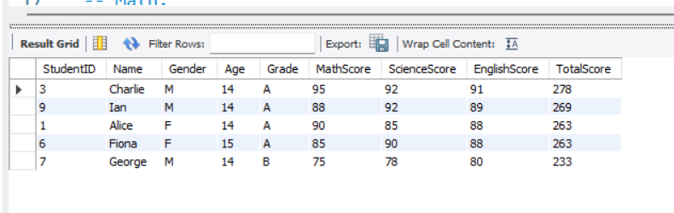
• SELECT Clause:
- StudentID, Name, Gender, Age, Grade, MathScore, ScienceScore, EnglishScore: These columns are selected from the Students table.
- (MathScore + ScienceScore + EnglishScore) AS TotalScore: This calculates the total score of each student by summing their scores in Math, Science, and English, and labels the result as TotalScore.
• FROM Students Clause:
- Specifies that the data is being retrieved from the Students table.
• ORDER BY TotalScore DESC Clause:
- Orders the result in descending order based on the TotalScore, meaning the student with the highest total score appears first.
• LIMIT 5 Clause:
- Restricts the result set to only the top 5 students with the highest TotalScore.

-- Calculate Averages Based on Specific Conditions
-- Use subqueries to filter and group data for average calculations:
-- ○ Example 1: Calculate the average score of students who scored above 70 in
-- Math.
-- ○ Example 2: Calculate the average total score of students grouped by a specific
-- condition, such as a score range (e.g., students scoring 200–250 in total).

SELECT
AVG((MathScore + ScienceScore + EnglishScore) / 3) AS AvgOverallScore
FROM
Students
WHERE
MathScore > 70;

• SELECT Clause:
- AVG((MathScore + ScienceScore + EnglishScore) / 3) AS AvgOverallScore:
  - Computes the overall score for each student by summing their MathScore, ScienceScore, and EnglishScore, then dividing by 3 to get the average subject score for each student.
  - The AVG() function then calculates the average of these overall scores across all students who meet the condition in the WHERE clause.
  - The result is given an alias AvgOverallScore.
• FROM Students Clause:
- Specifies that data is being retrieved from the Students table.
• WHERE MathScore > 70 Clause:
- Filters the records to include only students whose MathScore is greater than 70.
- This means only students who performed well in Math are considered in the average calculation.

SELECT
AVG(MathScore + ScienceScore + EnglishScore) AS AvgTotalScore
FROM
Students
WHERE
(MathScore + ScienceScore + EnglishScore) BETWEEN 200 AND 250;

• MathScore + ScienceScore + EnglishScore → Adds up the scores of three subjects for each student.
• WHERE (MathScore + ScienceScore + EnglishScore) BETWEEN 200 AND 250 → Filters only those students whose total score is between 200 and 250.
• AVG(MathScore + ScienceScore + EnglishScore) AS AvgTotalScore → Computes the average of these filtered students' total scores.

-- Find Second-Highest Math Scores
-- ● Use a subquery to determine the highest Math score and exclude it in a second query to
-- find the next highest value.
-- ● Example:
-- ○ Use MAX(math_score) in a subquery to find the highest score.
-- ○ Use WHERE math_score < (SELECT MAX(math_score) FROM
-- Students) to exclude the top score and then use MAX again to find the second
-- highest score.

SELECT
Name, MathScore
FROM
Students
WHERE
MathScore = (SELECT
MAX(MathScore)
FROM
Students
WHERE
MathScore < (SELECT
MAX(MathScore)
FROM
Students));

SELECT
Name, MathScore
FROM
Students
WHERE
MathScore = (subquery);
- This retrieves the Name and MathScore of the student(s) whose MathScore matches the result from the subquery.

2. First Subquery (Finding the Highest Math Score)
sql
CopyEdit
SELECT
MAX(MathScore)
FROM
Students;
- This retrieves the maximum MathScore in the Students table.

3. Second Subquery (Finding the Second-Highest Math Score)
sql
SELECT
MAX(MathScore)
FROM
Students
WHERE
MathScore < (SELECT MAX(MathScore) FROM Students);
- This retrieves the maximum MathScore that is less than the highest MathScore, effectively finding the second-highest MathScore.

